**Group No: 01**

**Course No**: CSE 308

**Course Name**: Software Design and Information System Design Sessional.

**Automation of BCB’s Game Development Committee**

**Group Members:**

1005091

1005111

1005113

1005115

1005120

**Introduction:**

Bangladesh cricket is one of the greatest prides for Bangladesh. Though Bangladesh cricket has advanced significantly in international level, unfortunately the domestic cricket management and maintenance has not been well-organized yet. Therefore, in spite of having lots of cricket loving talented players all over the country they are not inspired and utilized properly for sake of the Bangladesh cricket due to lack of seriousness and faulty system in the domestic cricket infrastructure. It is our belief that if we can improve this system to improve the domestic cricket infrastructure then no talent will be waste and our cricket will improve significantly.

**Subsystems:**

Our subsystems are:

* School Cricket Management System
* Youth Cricket Management System
* Facilities and Equipments Management System
* Divisional Cricket Management System
* Academy Operations Management System
* Coach Management System
* Control Management System

ERD of Our Game Development Committie:

1. **School Cricket Management System:**

***1.1 Entity Relationship Diagram (ERD):***

Tournaments

include

School tournaments

Ground

use

participatee

Registration Info

has

School

School tournaments

participatee

School

Figure 1.1.1:Entity-Relationships with attributes

School tournaments

use

Ground

Figure 1.1.2:Entity-Relationships with attributes

School tournaments

include

Tournaments

Figure 1.1.3:Entity-Relationships with attributes

Registration Info

has

School

Figure 1.1.4:Entity-Relationships with attributes

1. **Youth Cricket Management System:**

***2.1 Entity Relationship Diagram (ERD):***

Tournaments

include

Youth tournaments

participatee

use

Ground

Youth teams

Youth tournaments

participatee

Youth teams

Figure 2.1.1:Entity-Relationships with attributes

Youth tournaments

use

Ground

Figure 2.1.2:Entity-Relationships with attributes

Youth tournaments

include

Tournaments

Figure 2.1.3:Entity-Relationships with attribute

1. **Facilities Management System:**

***3.1 Entity Relationship Diagram (ERD):***



Figure 3.1:Entity-Relationships



Figure 3.1.1:Entity-Relationships with attributes

1. **Divisional Cricket Management System:**

***4.1 Entity Relationship Diagram (ERD):***

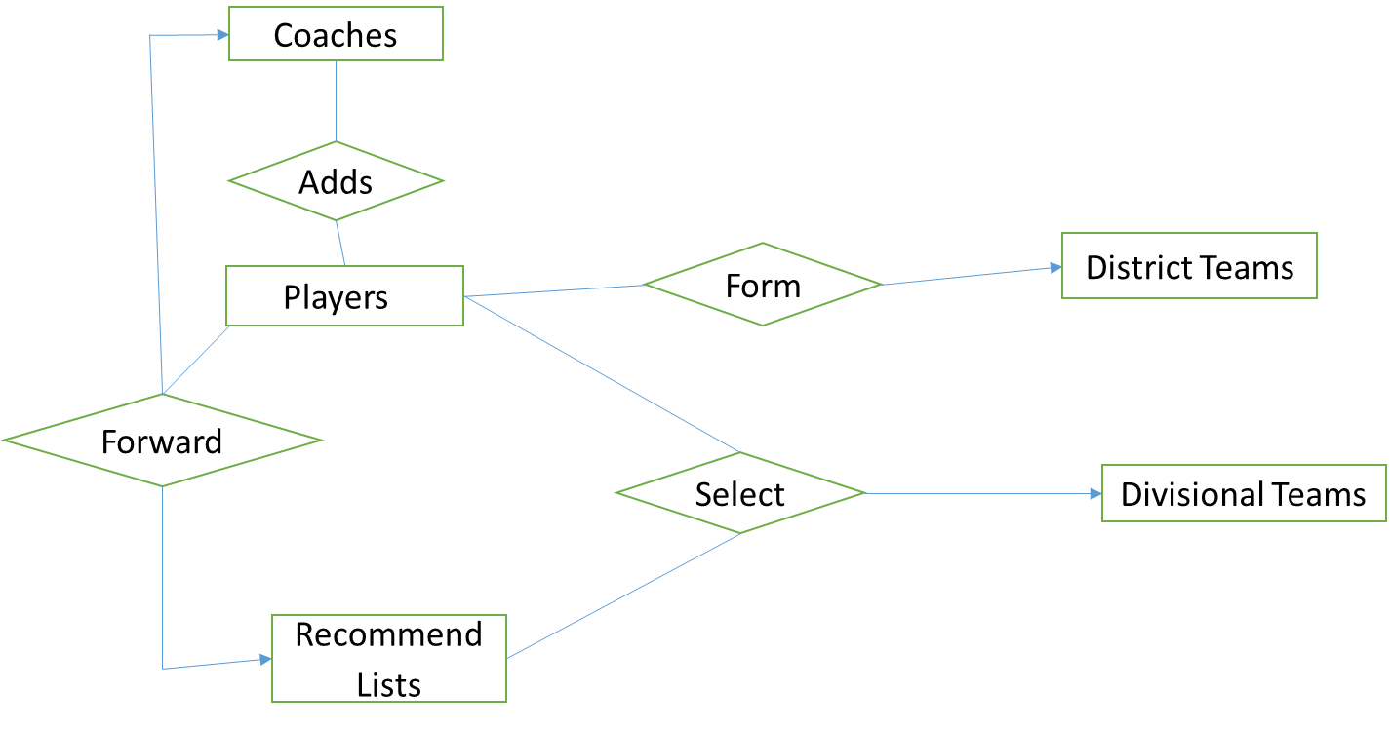

Figure 4.1:Entity-Relationships

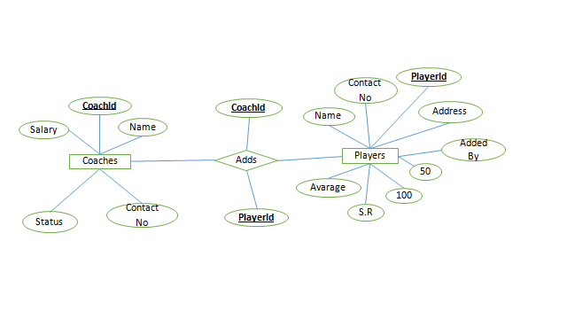

Figure 4.1.2:Entity-Relationships with attribute



Figure 4.1.3:Entity-Relationships with attribute



Figure 4.1.4:Entity-Relationships with attribute



Figure 4.1.5:Entity-Relationships with attribute

1. **Academy Operations Management**

***5.1 Entity Relationship Diagram (ERD):***

 Figure 5.1:Entity-Relationships



Figure 5.1.2:Entity-Relationships with attribute

 Figure 5.1.3:Entity-Relationships with attribute

1. **Control Management**

6.1 **Entity relationship diagram:**



Figure 6.1.1:Entity-Relationships with attribute



Figure 6.1.2:Entity-Relationships with attribute



Figure 6.1.3:Entity-Relationships with attribute



Figure 6.1.4:Entity-Relationships with attribute



Figure 6.1.4:Entity-Relationships with attribute



Figure 6.1.4:Entity-Relationships with attribute

***Database Schema Tables***

**School**

|  |  |
| --- | --- |
| Attribute Name | Data Type |
| SID | Number |
| Name | Varchar2 |
| Team Name | Varchar2 |
| Ranking | Number |
| Address | Varchar2 |
| Matches played | Number |
| Lost | Number |
| Won | Number |
|  |  |

**Youth teams**

|  |  |
| --- | --- |
| Attribute Name | Data Type |
| TeamID | Number |
| Name | Varchar2 |
| Manager | Varchar2 |
| Ranking | Number |
| Address | Varchar2 |
| Matches played | Number |
| Lost | Number |
| Won | Number |
|  |  |

**Youth Tournaments**

|  |  |
| --- | --- |
| Attribute Name | Data Type |
| TourID | Number |
| Name | Varchar2 |
| Age | Varchar2 |
| ChampionID | Number |
| RunnerupID | Number |
| No. of teams | Number |
| Start Date | Date |
| Player of Tournament | Varchar2 |

**School Tournaments**

|  |  |
| --- | --- |
| Attribute Name | Data Type |
| TourID | Number |
| Name | Varchar2 |
| No. of teams | Number |
| ChampionID | Number |
| RunnerupID | Number |
| Player of Tournament | Varchar2 |
| Start date | Date |

**Tournaments**

|  |  |
| --- | --- |
| Attribute Name | Data Type |
| TID | Number |
| Name | Varchar2 |
| Type | Varchar2 |

**Ground**

|  |  |
| --- | --- |
| Attribute Name | Data Type |
| GID | Number |
| Name | Varchar2 |
| Status | Varchar2 |
| Availibity | Varchar2 |
| Address | Varchar2 |
| Matches played | Number |
| Rating | Number |
| Revenue | Number |

**Registration Info**

|  |  |
| --- | --- |
| Attribute Name | Data Type |
| RegID | Number |
| Date | Date |
| Approval | Varchar2 |

**Facilities**

|  |  |
| --- | --- |
| Attribute Name | Data Type |
| FacilityID | Number |
| Name | Varchar2 |
| No. of Items Available | Number |
| Market Price | Number |

**Facility List**

|  |  |
| --- | --- |
| Attribute Name | Data Type |
| Name | Varchar2 |
| Ordered by | Varchar2 |
| No. of Items | Number |
| Date of Order | Date |
| Delivery report | Varchar2 |

**Provided Facilities**

|  |  |
| --- | --- |
| Attribute Name | Data Type |
| FacilityID | Number |
| Delivery Date | Date |
| Delivered to | Varchar2 |
| Total no. | Number |

**Players**

|  |  |
| --- | --- |
| Attribute Name | Data Type |
| PlayerID | Number |
| Name | Varchar2 |
| CoachID | Number |
| Added by | Varchar2 |
| Address | Varchar2 |
| Avarage | Number |
| S.R. | Number |
| 100s | Number |
| 50s | Number |
| Contact No. | Number |

**District Team**

|  |  |
| --- | --- |
| Attribute Name | Data Type |
| Name | Varchar2 |
| TeamID | Number |
| Manager Name | Varchar2 |
| Type | Varchar2 |
| District Name | Varchar2 |
| Division | Varchar2 |

**Coaches**

|  |  |
| --- | --- |
| Attribute Name | Data Type |
| CoachID | Number |
| Salary | Number |
| Name | Varchar2 |
| Status | Varchar2 |
| Contact No | Number |

**Division Team**

|  |  |
| --- | --- |
| Attribute Name | Data Type |
| Name | Varchar2 |
| TeamID | Number |
| Manager Name | Varchar2 |
| Type | Varchar2 |
| Division Name | Varchar2 |

**Recommended List**

|  |  |
| --- | --- |
| Attribute Name | Data Type |
| PlayerID | Number |

**Academy Players**

|  |  |
| --- | --- |
| Attribute Name | Data Type |
| ID | Number |
| Name | Varchar2 |
| Type | Varchar2 |
| Tactics | Varchar2 |
| stamina | Varchar2 |
| Effective area | Varchar2 |
| Lacking area | Varchar2 |
| Contact No. | Number |

**Academy Coaches**

|  |  |
| --- | --- |
| Attribute Name | Data Type |
| CoachID | Number |
| Name | Varchar2 |
| Rank | Varchar2 |
| Salary | Number |
| Service tenure | Varchar2 |

**Player list**

|  |  |
| --- | --- |
| Attribute Name | Data Type |
| PlayerID | Number |

**Report**

|  |  |
| --- | --- |
| Attribute Name | Data Type |
| ReportID | Number |
| Details | Varchar2 |

**National Manager**

|  |  |
| --- | --- |
| Attribute Name | Data Type |
| ID | Number |
| Name | Varchar2 |
| Remark | Varchar2 |
| Service period | Varchar2 |

**OperationalManager**

|  |  |
| --- | --- |
| Attribute Name | Data Type |
| ID | Number |
| Name | Varchar2 |
| Remark | Varchar2 |
| UnderOfficerID | Number |
| Service period | Varchar2 |

**Program Manager**

|  |  |
| --- | --- |
| Attribute Name | Data Type |
| ID | Number |
| Name | Varchar2 |
| Remark | Varchar2 |
| UnderOfficerID | Number |
| Service period | Varchar2 |

**Divisional Cricket Administrator**

|  |  |
| --- | --- |
| Attribute Name | Data Type |
| ID | Number |
| Name | Varchar2 |
| Remark | Varchar2 |
| UnderOfficerID | Number |
| Service period | Varchar2 |

**Academy Operation Manager**

|  |  |
| --- | --- |
| Attribute Name | Data Type |
| ID | Number |
| Name | Varchar2 |
| Remark | Varchar2 |
| UnderOfficerID | Number |
| Service period | Varchar2 |

**Manager Coaches**

|  |  |
| --- | --- |
| Attribute Name | Data Type |
| ID | Number |
| Name | Varchar2 |
| Remark | Varchar2 |
| UnderOfficerID | Number |
| Service period | Varchar2 |

Triggers:

|  |  |  |  |  |
| --- | --- | --- | --- | --- |
| **Trigger Name:** | | **Registration** | | |
| Execution Time: | | After Accepted The Registration Form | | |
| Actions | | | |  |
| Commands | Attributes | | Tables | Remarks |
| Update | Approval | | RegistrationInfo | Update Registration Info |
| Insert | Name,team | | School | Accepted school are Listed |

|  |  |  |  |  |
| --- | --- | --- | --- | --- |
| **Trigger Name:** | | **Arrange School Tournament** | | |
| Execution Time: | | After Registration Is Completed | | |
| Actions | | | |  |
| Commands | Attributes | | Tables | Remarks |
| Update | Arrange Date | | Tournaments | Update Tournament Status |
| Update | Status ,Avalibility | | Ground | Ground Database Is Updated |

|  |  |  |  |  |
| --- | --- | --- | --- | --- |
| **Trigger Name:** | | **Arrange Youth Tournament** | | |
| Execution Time: | | After Youth Tournament Sceduled | | |
| Actions | | | |  |
| Commands | Attributes | | Tables | Remarks |
| Update | Arrange Date | | Tournaments | Update Tournament Status |
| Update | Status ,Avalibility | | Ground | Ground Database Is Updated |

|  |  |  |  |  |
| --- | --- | --- | --- | --- |
| **Trigger Name:** | | **Facility** | | |
| Execution Time: | | When Facility Is Approved | | |
| Actions | | | |  |
| Commands | Attributes | | Tables | Remarks |
| Update | NoOfItems | | Facility | Decrese No of Items In Stored Facilities |
| Insert | DeliveryDate,DeliveredTo | | ProvidedFacilities | Insert Into Provided Facilities |

|  |  |  |  |  |
| --- | --- | --- | --- | --- |
| **Trigger Name:** | | **Formation Of Academy Team & Coaches** | | |
| Execution Time: | | After Completing Of Youth Cricket Tournament | | |
| Actions | | | |  |
| Commands | Attributes | | Tables | Remarks |
| Insert/Update | Playername | | Players | New Academy Players Are Include In the Teams And Some Are Updated |
| Update/Delete | Coachname | | Coach | Coaches of academy teams are updated by academy operation Manager |

|  |  |  |  |  |
| --- | --- | --- | --- | --- |
| **Trigger Name:** | |  | | |
| Execution Time: | | After Completing Of Youth Cricket Tournament | | |
| Actions | | | |  |
| Commands | Attributes | | Tables | Remarks |
| Insert/Update | Playername | | Players | New Academy Players Are Include In the Teams And Some Are Updated |
| Update/Delete | Coachname | | Coach | Coaches of academy teams are updated by academy operation Manager |

Procedures:

|  |  |  |
| --- | --- | --- |
| **Procedure Name** | **playerstats** | |
| **Time of Execution** | After a match played | |
| **Input** | Run,wicket,ball | |
| **Output** | Avg,strikerate,total run | |
| **Apply to** | Every PlayerId | |
|  | | |
| **Actions** | | **Remarks** |
| SELECT match played,run,avg,strike rate | | Player stats are updated after every match |

|  |  |  |
| --- | --- | --- |
| **Procedure Name** | **TournamentStats** | |
| **Time of Execution** | After strarting any tournament | |
| **Input** | MatchId | |
| **Output** | Match result | |
| **Apply to** | Every PlayerId | |
|  | | |
| **Actions** | | **Remarks** |
| SELECT reselts from tournament info | | Tournament stats are updated along with player stats |

|  |  |  |
| --- | --- | --- |
| **Procedure Name** | **FacilityCheck** | |
| **Time of Execution** | When facilities are asked for | |
| **Input** | FacilityId | |
| **Output** | Avaliable or not | |
| **Apply to** | On any facility from facility list | |
|  | | |
| **Actions** | | **Remarks** |
| SELECT facilityId,name from facilities | | Facility list will be checked if it is available or given already |

|  |  |  |
| --- | --- | --- |
| **Procedure Name** | **tournamentScheduling** | |
| **Time of Execution** | Before Arrenging a tournament | |
| **Input** | Date,Ground | |
| **Output** |  | |
| **Apply to** | Tournament | |
|  | | |
| **Actions** | | **Remarks** |
| Insert MatchId, Date,Ground | | Facility list will be checked if it is available or given already |

|  |  |  |
| --- | --- | --- |
| **Procedure Name** | **FacilityCheck** | |
| **Time of Execution** | When facilities are asked for | |
| **Input** | FacilityId | |
| **Output** | Avaliable or not | |
| **Apply to** | On any facility from facility list | |
|  | | |
| **Actions** | | **Remarks** |
| SELECT facilityId,name from facilities | | Facility list will be checked if it is available or given already |